***RV Coriolis* - range of applications in coastal research May ,2023** 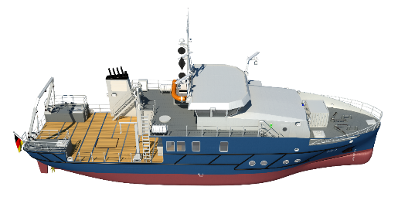

The research vessel *Coriolis* is essential for the coastal research in Germany. Due to its compact size and shallow draft, the *Coriolis* can easily navigate rivers, shallow water areas such as the Wadden Sea, but also deeper waters of the North Sea and Baltic Sea.

**Research tasks:**

- Investigation of organic pollutants in air, seawater and sediments in German rivers and the North Sea.

- Identification of potential inorganic pollutants that could have a relevant input into the marine environment through the corrosion protection of offshore renewable energy, such as offshore wind farms.

- Determination of pollutants such as heavy metals (cadmium, mercury, copper and zinc), pesticides and industrial chemicals.

- Determination of suspended solids, oxygen, salinity ... that enter the North in order to obtain reference measurements for extreme events (floods).

- Recording the distribution and abundance of sea ducks and other seabirds.

- Determination of substance and nutrient transport, nitrate and greenhouse gas concentrations.

- Testing of new devices and sensors. Mooring of measuring buoys.

- Training of students

**Equipment:**

* Wet and e-lab
* Buoys can also be deployed from on board the Coriolis, as well as ground-based measuring systems such as underwater nodes and landers.
* Hydrographic shaft with which scientific instruments can be deployed directly from inside the ship to the keel line.
* Ultra-pure seawater intake-system for (ultra-)trace analysis.
* The built-in FerryBox can be registered online and continuously measures physical, chemical and biological parameters such as oxygen concentration, salinity, temperature or pH value - during the voyage and in port.
* Hydroacoustic systems for current measurement (echosounder and ADCP) are provided in the bottom of the ship.