***RV Coriolis* - Technology Demonstrator (real scale lab) May , 2023**

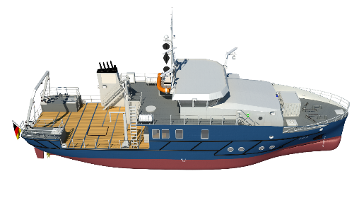

*Coriolis* will cover an interdisciplinary spectrum of coastal, materials, hydrogen and membrane research as well as set new standards in digitalization.

**Research tasks:**

* Testing of new energy systems with a focus on hydrogen technology (100 kW fuel cell - 5t metal hydride tank) - Inst. f. Hydrogen Technology - Cooperation with the new DLR Inst. f. Maritime
* Treatment of engine charge air to minimize pollutant emissions with membranes.
* System development of safe and compact storage of hydrogen (metal hydride) on board ships

**Equipment:**

The innovative propulsion system consists of electric traction motors that can access various power storage units. One of these is a specially developed tank system in which hydrogen is stored in the form of metal hydrides. This enables the testing and establishment of hydrogen technologies.

A membrane module will be attached to the engine that separates the oxygen from the combustion air. In return, the built-in membrane allows oxygen to flow through better than nitrogen. This lowers the oxygen content in the retained combustion air - in this case from 21% by volume to about 18% by volume. As a result, the temperature of the combustion air also drops. In addition, if this temperature drops, the proportion of nitrogen oxides produced during combustion drops. Thus, nitrogen emissions are reduced by 80%.

**Gain of Expertise/Competence:**

- Integration of thermal, control and electrical systems into the existing ship structure and interfaces

- Maritime classification of hydrogen infrastructure (environmentally friendly shipping)

- Simulation of metal hydride storage

- Simulation and testing of fluidic properties of the ship

- Reduction of marine diesel engine emissions by membranes

- Modelling of ship emissions

- Digital data sets: environmental, propulsion, corrosion…