**Venue:**

Institute of Anatomy

University of Bern

Bühlstrasse 26

3012 Bern

**Directions:**

<https://www.bing.com/maps?&cp=46.951595~7.423818&lvl=16&pi=0&tstt0=Institut%20f%C3%BCr%20Anatomie&tsts0=%2526ty%253D18%2526q%253Dinstitut%252520f%2525C3%2525BCr%252520anatomie%25252C%252520bern%2526ss%253Dypid.YN9003x3116201%2526mb%253D46.955081~7.420814~46.948109~7.437465%2526description%253DBaltzerstrasse%2525202%252520%2525C2%2525B7%2525203012%252520Bern%2525C2%2525B7Hochschule%25252FUniversit%2525C3%2525A4t%2526cardbg%253D%25252388979C%2526dt%253D1741680000000&ftst=0&ftics=False&v=2&sV=2&form=S00027>

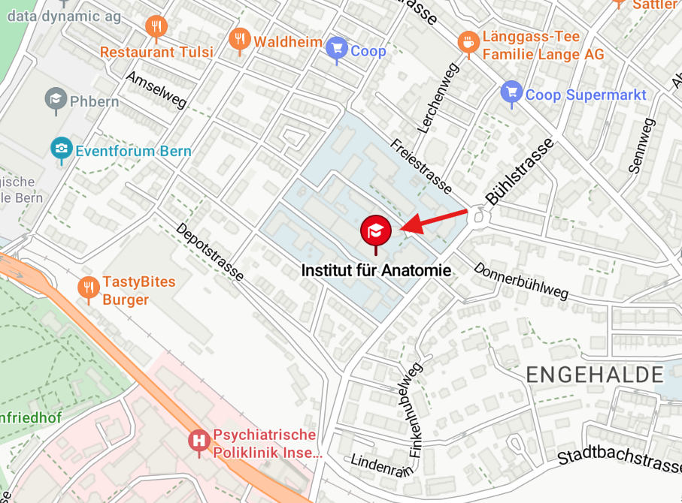

**Accommodation:** We have arranged exclusive discounts with partner hotels in Bern for the duration of the workshop (October 16-19). Please choose from our recommended hotels and book your stay at a special rate. Please be aware of the limited room availability  – and book early to ensure your stay!

**\*\* Only by emailing the Hotel you will benefit from the exclusive discount \*\***

1. Choose the hotel fitting best to your preferences:

**Hotel 1:**  [**www.sorellhotels.com/de/hotels/ador-bern**](http://www.sorellhotels.com/de/hotels/ador-bern)

[ador@sorellhotels.com](mailto:ador@sorellhotels.com)

**Hotel 2:**  [**www.sorellhotels.com/de/hotels/arabelle-bern**](http://www.sorellhotels.com/de/hotels/arabelle-bern)

[arabelle@sorellhotels.com](mailto:arabelle@sorellhotels.com)

1. **Prices** (per night) are the same for either Hotel. They include breakfast.

|  |  |  |  |  |
| --- | --- | --- | --- | --- |
| **Category** | **Stay** | **Nights** | **Daily Room Rate (Monday-Friday)** | **Daily Room Rate (Friday-Monday)** |
| Standard Single Room | 16.10.2025 - 19.10.2025 | 3 | CHF 165.00 | CHF 145.00 |
| Standard Double Room for Single Occupancy | 16.10.2025 - 19.10.2025 | 3 | CHF 195.00 | CHF 165.00 |

1. **You must Email** the respective Hotel to obtain the discount.
2. Indicate the discount code **CARAT4**
3. Include the length of you stay